**Q.1. Create a database named 'custom'. Create a table named temperature_data inside custom having below fields: 1. date (mm-ddyyyy) format 2. zip code 3. temperature The table will be loaded from comma-delimited file. Load the dataset.txt (which is ',' delimited) in the table.**

**Input data for inserting into the table:**

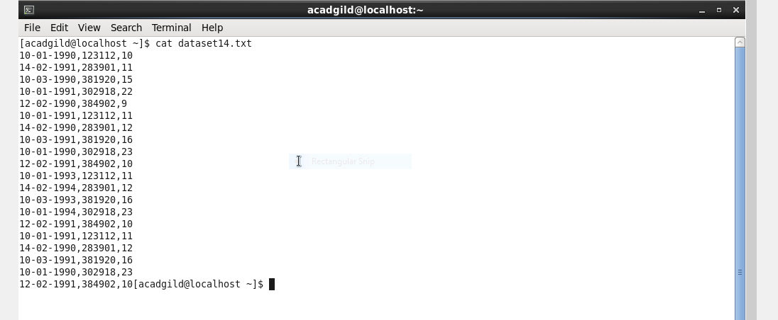

**Create database:**

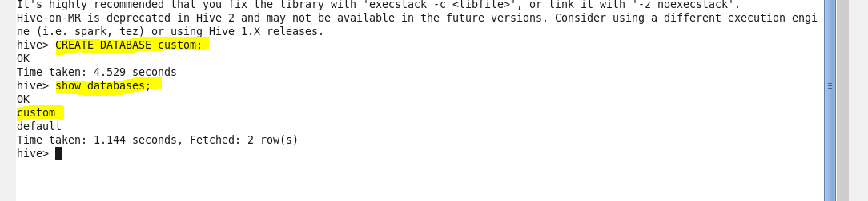

**Use database custom:**



**Create table temperature_data with comma delimited:**

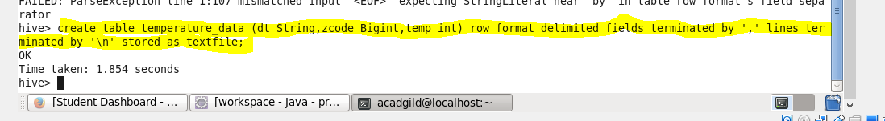

**Show table:**

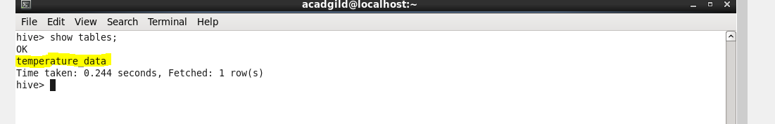

**Load the data into the table:**

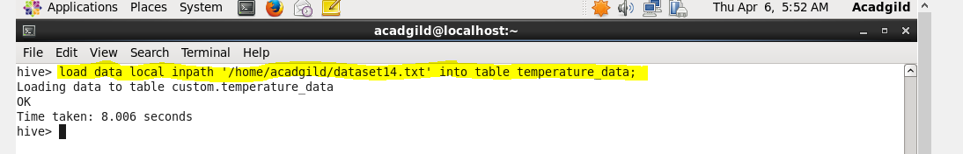

**Display the content of the table:**

